

Technical Implement Document for Configuring Backups
  - National Transport Authority
  - CABS SQL Database Level Backups Plan

Prepared by Ajatha
aindira@openskydata.com



Purpose
Technical implementation document for CABS SQL Database Level Backups through SQL Server Maintenance wizard and SQL Server agent jobs.

Scope of Document
This document outlines the main procedural steps to implement SQL Database Level Backups

Storage options within existing NTA's infrastructure
Prerequisite:
  - NTA/Trilogy to provide a Network Share Drive with approx. 1 TB of free space to store backups.
  - Once the shared driver space is made available, create three different folders to store Full, differential and transaction log backups and then follow the process.

CABS SQL Database Backups and Schedule:
  - Full DB backup: Occurs every week on Sunday at 4:00:00 PM
  - Differential backups: Occurs every day except Sunday
(Monday, Tuesday, Wednesday, Thursday, Friday, Saturday at 9:00:00 PM)
  - Transaction logs: Occurs every day every 2 hour(s) between 7:00:00 AM and 7:15:00 PM

Retention Policy
The retention policy for these DB backups is 3 full backups - backup is generated older than 21 days will be automatically deleted by a cleanup job before executing the current backup.

Configuring Database FULL backups using SQL Server Built-in Maintenance Task
The following steps explain how to set up an MS SQL maintenance plan for the CABS databases using the Maintenance Plan Wizard.
- In SQL Server Management Studio, Go to Management and right-click Maintenance Plans, and then click Maintenance Plan Wizard.

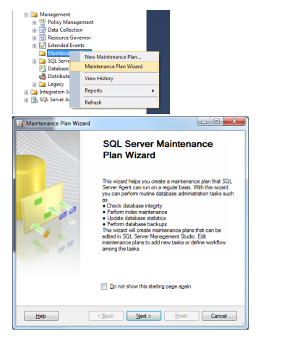
- Click Next and give the Name: MaintenancePlanFullBkp

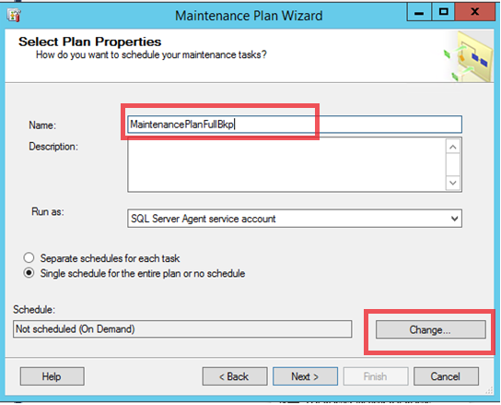
- Click on Change... button under Schedule: and change as below schedule mentioned in Red.

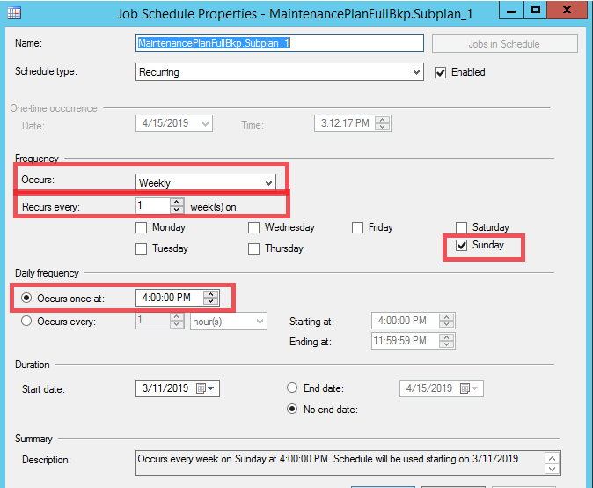
- Click Next and select the below three tasks
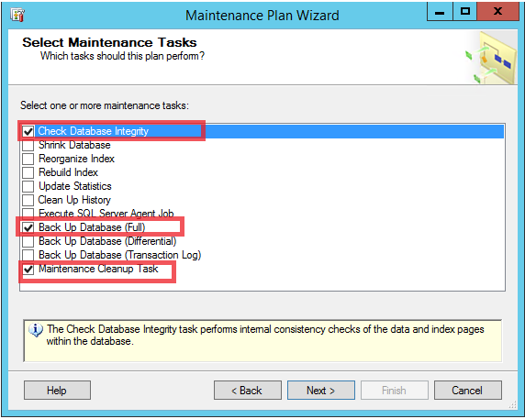
- Rearrange the order in such a way that Cleanup task is in first place and second one for Backup and third as Integrety task
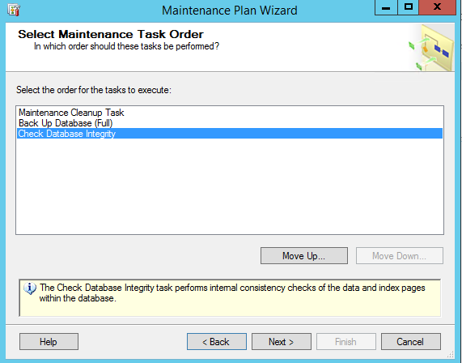

- Click Next
- Define Maintenance Cleanup Task Parameters:
- Select the dedicated folder for full backups as mentioned in the prerequisites. And mention the retention (File age) as 21 days

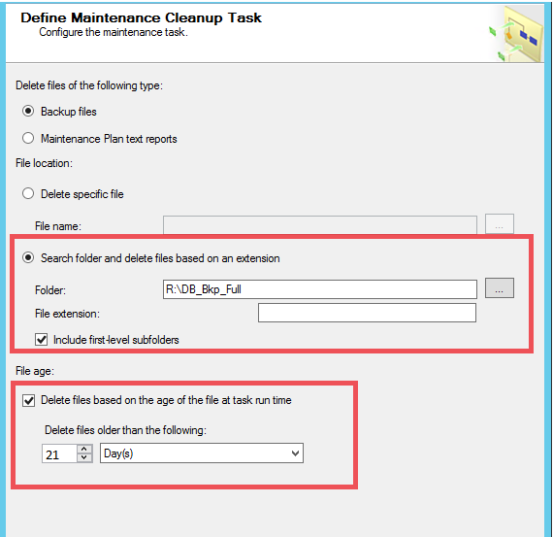

- Define Database Full Backup Task:
- Go to General tab
- Select the two red highlighted options from the dropdown for Database(s) option
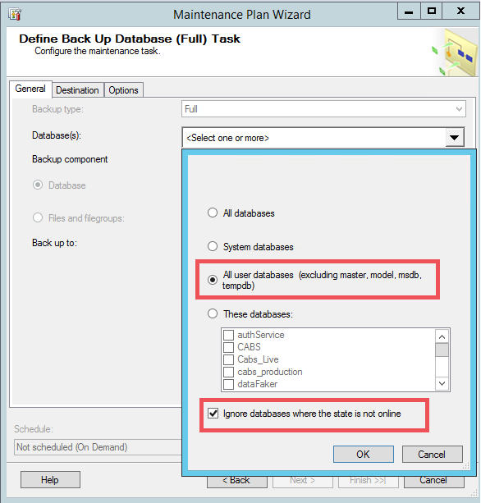
- Click Ok
- Select Backup to Disk
- Go to Destination Tab
- Go to highlighted options and mention the destination path for the full backups of user databases.
- *** Select the dedicated folder for full backups as mentioned in the prerequisites to avoid confusion

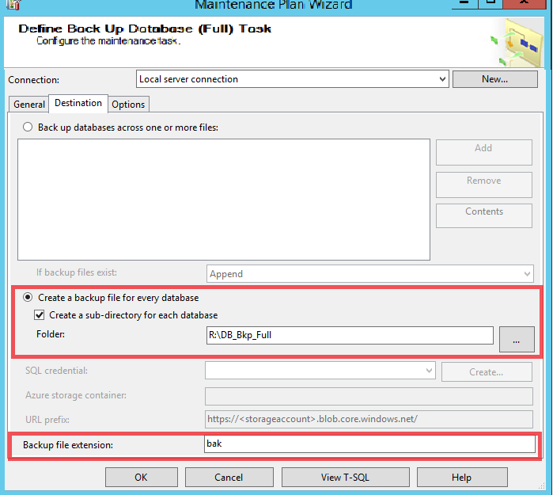

- Go to Options tab and checkmark the below three options
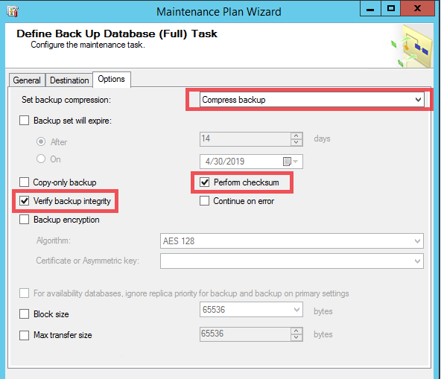

- Next the wizard drives us to Integrity check task, please select the user databases from the drop down as mentioned below
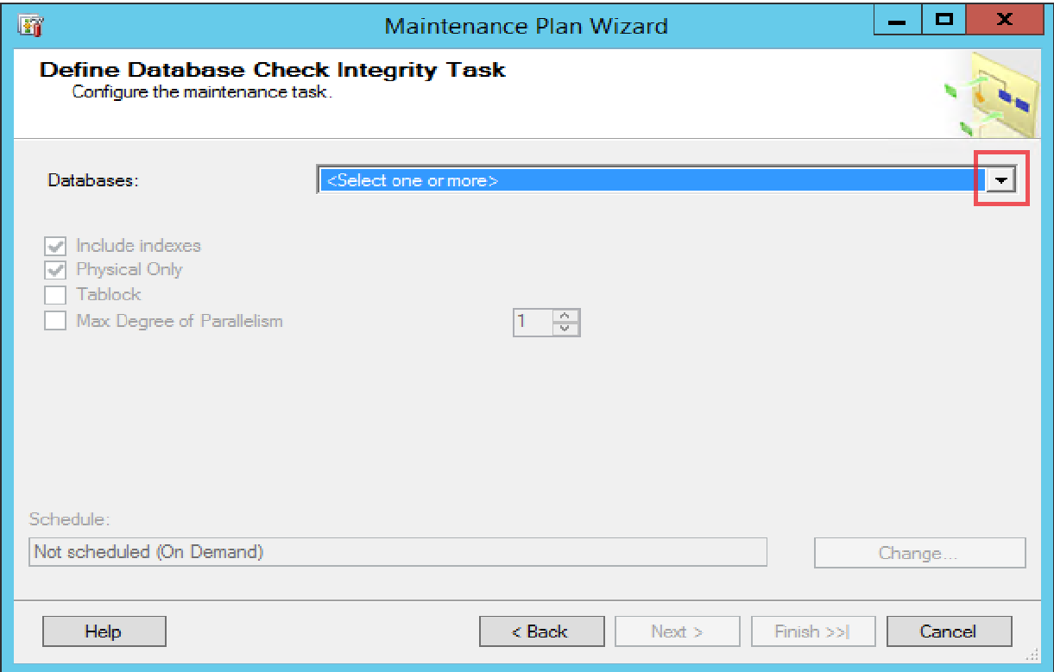
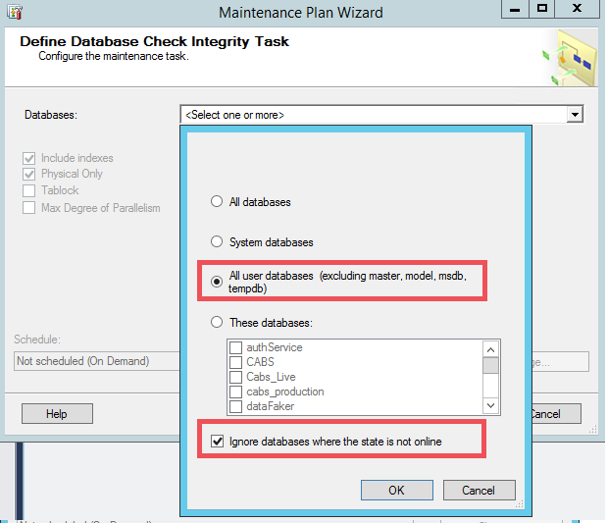
- Select option Physical Only option for integrity check as mentioned below
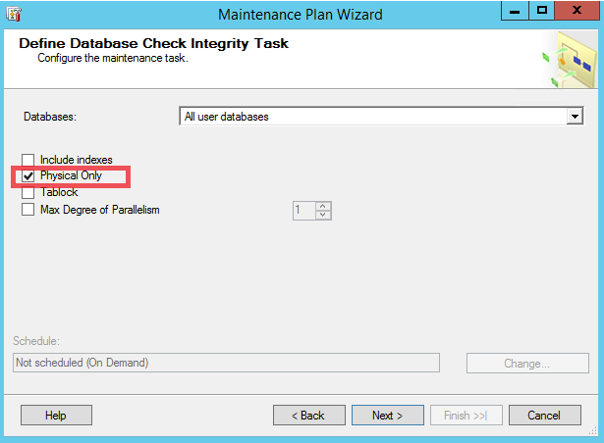
- Click on Next and give valid Email address for sending a report of configuration setting.
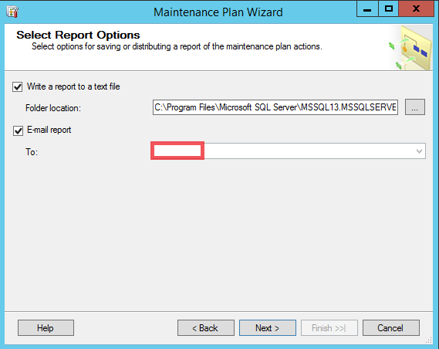
- Click Next and Finish

Configuring Database Differential backups using SQL Server Built-in Maintenance Task

- In SQL Server Management Studio, Go to Management and right-click Maintenance Plans, and then click Maintenance Plan Wizard.

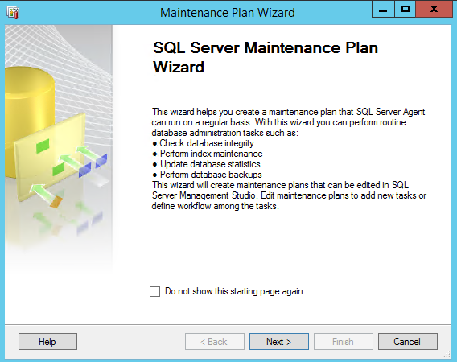
- Give a meaning full name for Differential backup task and Click on Change... button under Schedule: and change as below schedule mentioned in Red.
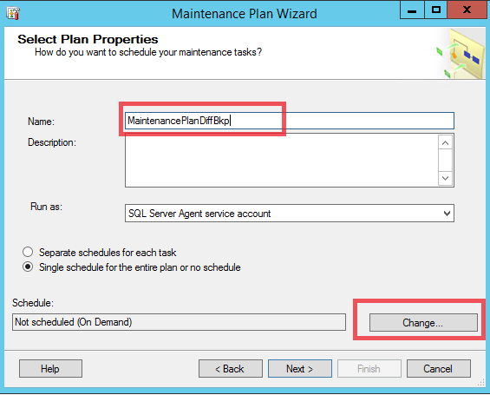
- Select the below schedule:
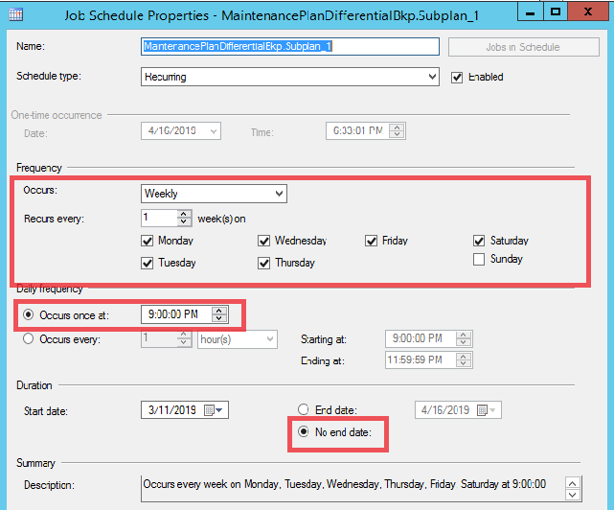

- Select the below two tasks as mentioned in Red

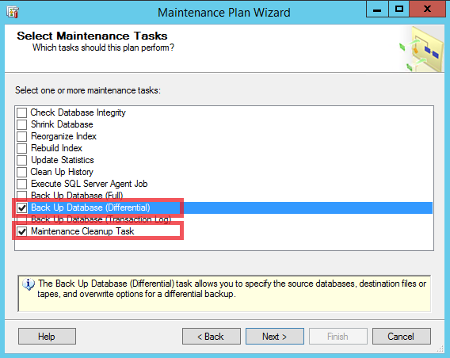
- Rearrange the order in such a way that Cleanup task is in first place and second one for Differential Backup
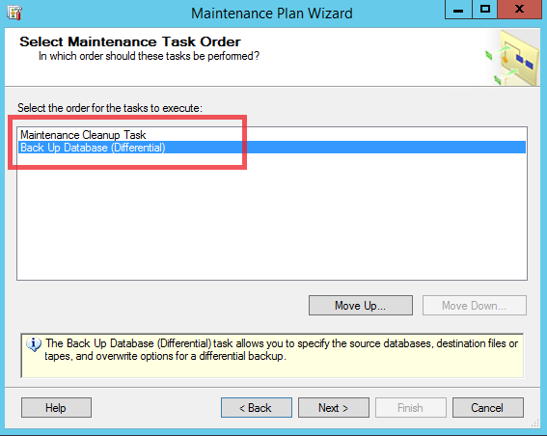

- Select the dedicated folder for Differential backups as mentioned in the prerequisites. And mention the retention (File age) as 21 days
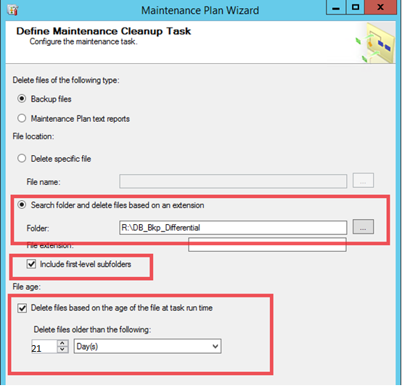

- Define Database Differential Backup Task:
- Go to General tab
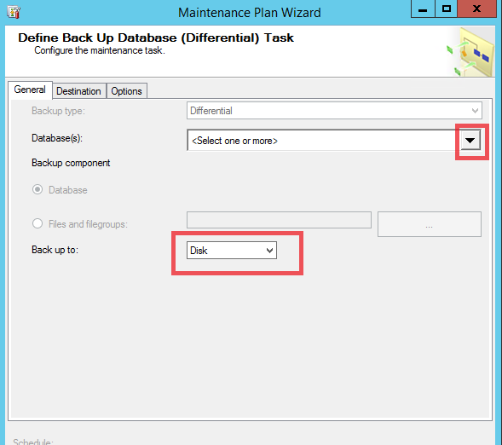
- Select the two red highlighted options from the dropdown for Database(s) option

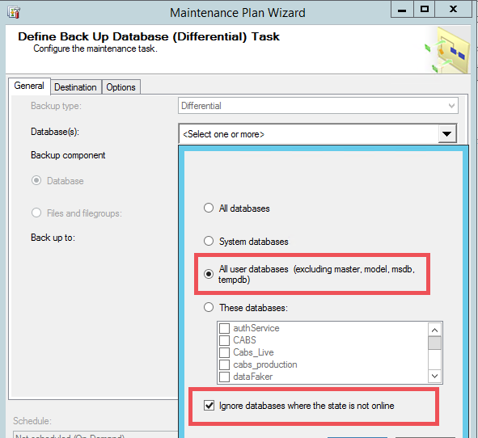
- Go to Destination Tab
- Go to highlighted options and mention the destination path for the Differential backups of user databases.
- *** Select the dedicated folder for Differential backups as mentioned in the prerequisites to avoid confusion

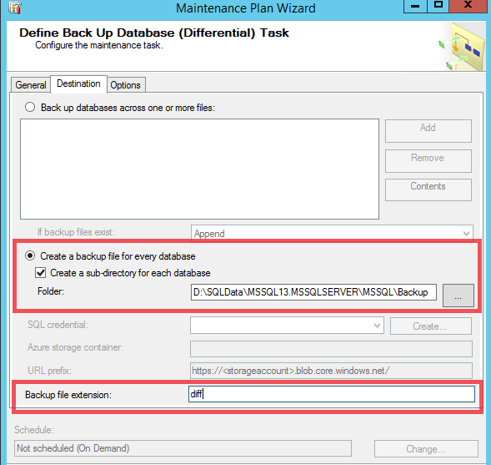
- Go to Options tab and checkmark the below three options

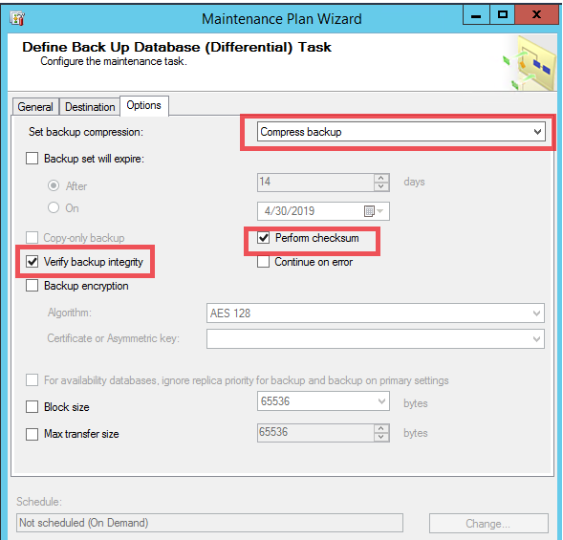

- Click Next and Finish

Configuring Database Transactional log backups using SQL Server Built-in Maintenance Task

- In SQL Server Management Studio, Go to Management and right-click Maintenance Plans, and then click Maintenance Plan Wizard.

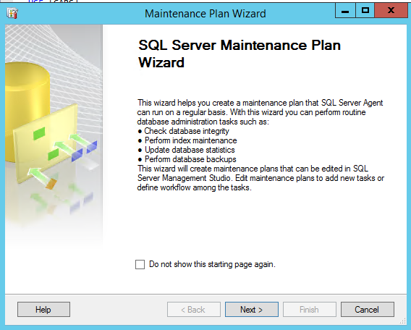
- Give a meaning full name for Transactional log backup task and Click on Change... button under Schedule: and change as below schedule mentioned in Red.

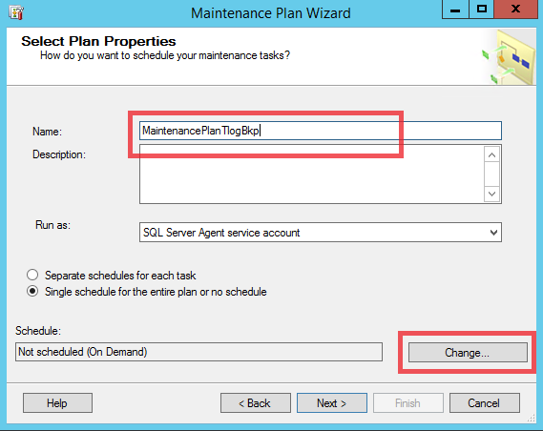
- Select the below schedule:
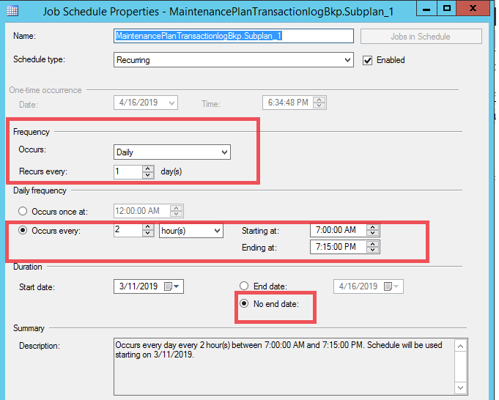
- Click Next and select the below two options
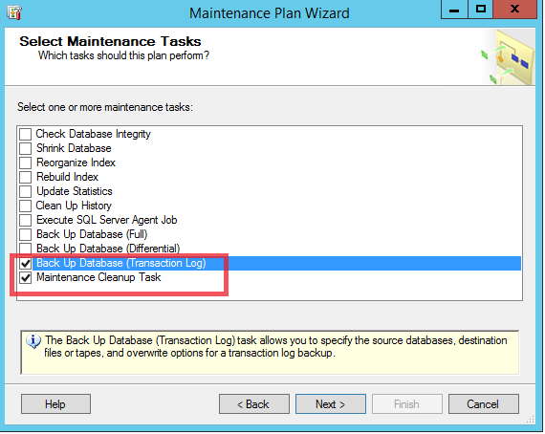
- Rearrange the order in such a way that Cleanup task is in first place and second one for Transaction log Backup

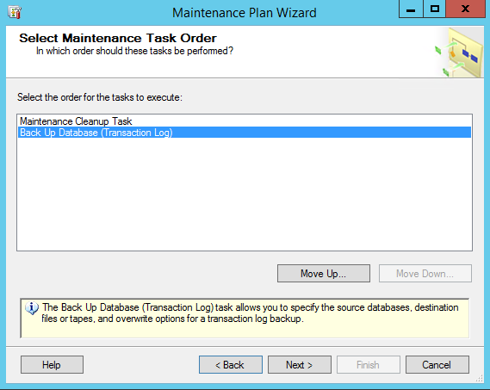
- Select the dedicated folder for Transaction Log backups as mentioned in the prerequisites. And mention the retention (File age) as 21 days

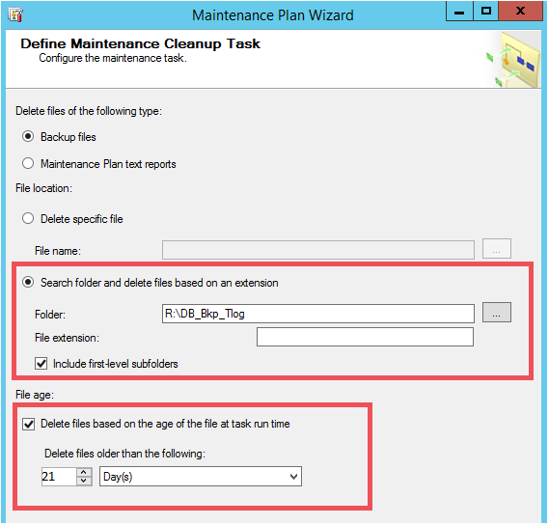
- Define Database Transaction Log Backup Task:
- Go to General tab

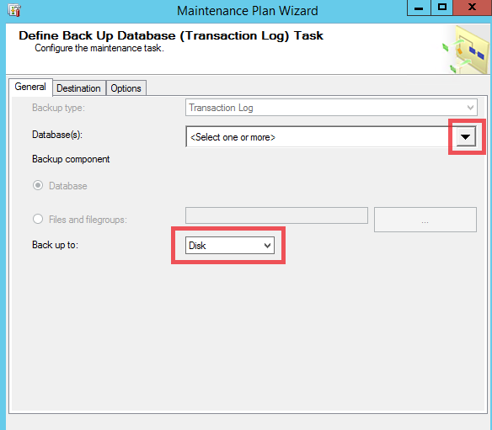
- Select the two red highlighted options from the dropdown for Database(s) option

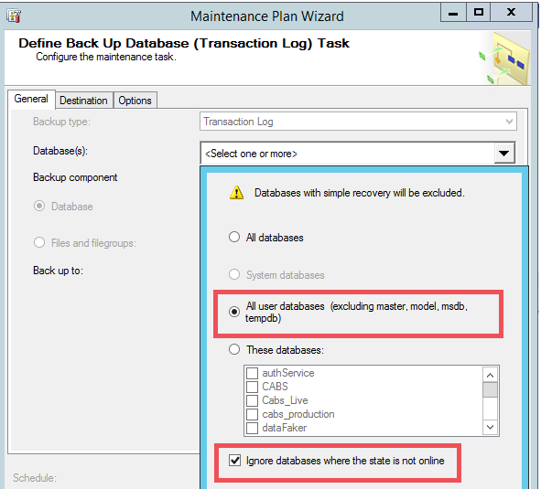

- Go to Destination Tab
- Go to highlighted options and mention the destination path for the Transaction Log backups of user databases.
- *** Select the dedicated folder for Transaction Log backups as mentioned in the prerequisites to avoid confusion

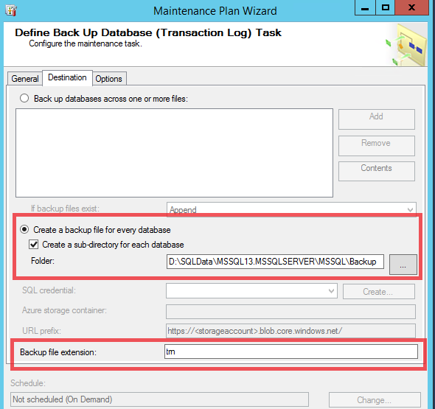
- Go to Options tab and checkmark the below three options

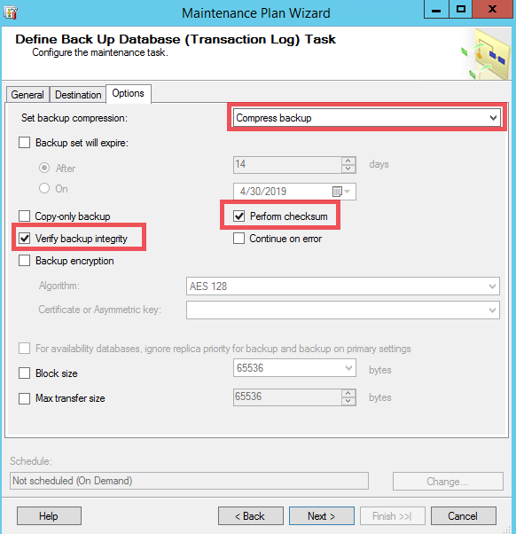
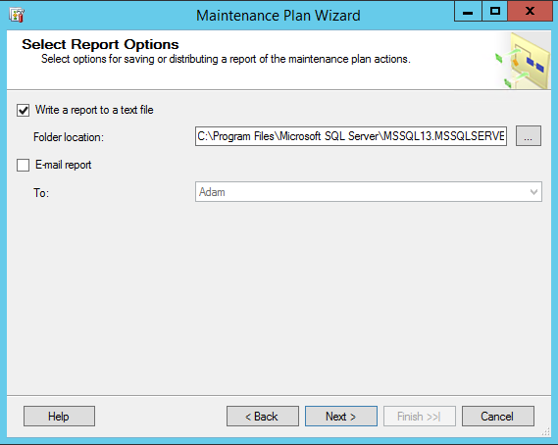
Click Next and Finish

